4
_______________█_______________

Do You Know Your Bible?

Thirty Questions that Will Help You Test Your Knowledge of the Bible
_____________________

If you did not belong to any church, had nothing to gain or lose; if you could read the Bible, and let it say what it says without trying to make it say what you want it to say, how would you answer these questions?

1. How could you prove the men who wrote the Bible were inspired by God?
2. Is God's church an organization or an organism?
3. How and when did Jesus become the door into the church?
4. What is the new and living way spoken of in Heb. 10:20?
“By a new and living way, which he hath consecrated for us, through the veil, that is to say, his flesh;”
5. How, when, and where, will the Battle of Armageddon be fought?
6. Are we living in the end of this age?
7. Do Christians have a body in heaven before the resurrection of the dead?
8. What will be our mode of travel in heaven?
9. Since God is all powerful, why does He allow sin and the Devil to exist?
10. Where are the dead?
11. The Beast and the woman of Rev. 17th Chapter, what do they represent?
12. Is the Lord God of the Old Testament, and the Lord Jesus of the New Testament one Lord or two Lords?
13. Why does God allow wars, cyclones, earthquakes, and other disasters?
14. What is the secret of victory, and Spiritual power?
15. What is the unpardonable sin?
16. The time worn question, which church is right?

28
Do You Know Your Bible?

17. Was Jesus the Christ the Eternal Son of God manifest in the flesh, or was He the Eternal Father manifest in the Son? Read I Tim. 3:16 and II Cor. 5:19.
“And without controversy great is the mystery of godliness: God was manifest in the flesh, justified in the Spirit, seen of angels, preached unto the Gentiles, believed on in the world, received up into glory.” 1 Tim 3:16
“To wit, that God was in Christ, reconciling the world unto himself, not imputing their trespasses unto them; and hath committed unto us the word of reconciliation.” 2 Cor 5:19
18. If praying through is all there is to being saved, why was it that Saul prayed for three days and did not get through until Ananias came and told him what to do? Read Acts 9:1-11 and 22:10-16.
Acts 9:1-11 “And Saul, yet breathing out threatenings and slaughter against the disciples of the Lord, went unto the high priest, And desired of him letters to Damascus to the synagogues, that if he found any of this way, whether they were men or women, he might bring them bound unto Jerusalem. And as he journeyed, he came near Damascus: and suddenly there shined round about him a light from heaven: And he fell to the earth, and heard a voice saying unto him, Saul, Saul, why persecutest thou me? And he said, Who art thou, Lord? And the Lord said, I am Jesus whom thou persecutest: it is hard for thee to kick against the pricks. And he trembling and astonished said, Lord, what wilt thou have me to do? And the Lord said unto him, Arise, and go into the city, and it shall be told thee what thou must do. And the men which journeyed with him stood speechless, hearing a voice, but seeing no man. And Saul arose from the earth; and when his eyes were opened, he saw no man: but they led him by the hand, and brought him into Damascus. And he was three days without sight, and neither did eat nor drink. And there was a certain disciple at Damascus, named Ananias; and to him said the Lord in a vision, Ananias. And he said, Behold, I am here, Lord. And the Lord said unto him, Arise, and go into the street which is called Straight, and inquire in the house of Judas for one called Saul, of Tarsus: for, behold, he prayeth,”
Acts 22:10-16 “And I said, What shall I do, Lord? And the Lord said unto me, Arise, and go into Damascus; and there it shall be told thee of all things which are appointed for thee to do. And when I could not see for the glory of that light, being led by the hand of them that were with me, I came into Damascus. And one Ananias, a devout man according to the law, having a good report of all the Jews which dwelt there, Came unto me, and stood, and said unto me, Brother Saul, receive thy sight. And the same hour I looked up upon him. And he said, The God of our fathers hath chosen thee, that thou shouldest know his will, and see that Just One, and shouldest hear the voice of his mouth. For thou shalt be his witness unto all men of what thou hast seen and heard. And now why tarriest thou? arise, and be baptized, and wash away thy sins, calling on the name of the Lord.”

19. It is a fact that God cannot die, it is also a fact that man cannot save from sin; therefore, a Saviour would have to be both God and man, one who could both die and save. How was this brought about?
20. If the Father is the only true God according to John 17:3, how can Jesus be the only wise God according to I Tim.1:17 and Jude 1:25? Are you sure you understand Isa. 9:6 and John 14:7-11?
John 17:3 “And this is life eternal, that they might know thee the only true God, and Jesus Christ, whom thou hast sent.”
1 Tim 1:17 “Now unto the King eternal, immortal, invisible, the only wise God, be honour and glory for ever and ever. Amen.”
Jude 25 “To the only wise God our Saviour, be glory and majesty, dominion and power, both now and ever. Amen.”
Isa 9:6 “For unto us a child is born, unto us a son is given: and the government shall be upon his shoulder: and his name shall be called Wonderful, Counseller, The mighty God, The everlasting Father, The Prince of Peace.”

29
Doctrinal Truths of the Bethel Ministerial Association

John 14:7-11 “If ye had known me, ye should have known my Father also: and from henceforth ye know him, and have seen him. Philip saith unto him, Lord, shew us the Father, and it sufficeth us. Jesus saith unto him, Have I been so long time with you, and yet hast thou not known me, Philip? he that hath seen me hath seen the Father; and how sayest thou then, Shew us the Father? Believest thou not that I am in the Father, and the Father in me? the words that I speak unto you I speak not of myself: but the Father that dwelleth in me, he doeth the works. Believe me that I am in the Father, and the Father in me: or else believe me for the very works' sake.”

21. What is the Christian Sabbath?
22. When did the Sonship of Jesus begin?
23. When did the church age begin?
24. What is the Great Tribulation spoken of in Mat. 24:15-22? Read it.
“When ye therefore shall see the abomination of desolation, spoken of by Daniel the prophet, stand in the holy place, (whoso readeth, let him understand:) Then let them which be in Judaea flee into the mountains: Let him which is on the housetop not come down to take any thing out of his house: Neither let him which is in the field return back to take his clothes. And woe unto them that are with child, and to them that give suck in those days! But pray ye that your flight be not in the winter, neither on the sabbath day: For then shall be great tribulation, such as was not since the beginning of the world to this time, no, nor ever shall be. And except those days should be shortened, there should no flesh be saved: but for the elect's sake those days shall be shortened.”

25. Will the church go through the Great Tribulation?
26. Does I Sam., 28th Chapter, uphold spiritualism?
27. Is Eternal Security conditional or un-conditional ?
28. Who was Melchisedec? Read Heb. 7:1-3.
“For this Melchisedec, king of Salem, priest of the most high God, who met Abraham returning from the slaughter of the kings, and blessed him; To whom also Abraham gave a tenth part of all; first being by interpretation King of righteousness, and after that also King of Salem, which is, King of peace; Without father, without mother, without descent, having neither beginning of days, nor end of life; but made like unto the Son of God; abideth a priest continually.”
29. Will the Dictators conquer the world or will they be subdued?
30. Can divorced persons be saved?

DO YOU KNOW it is a miracle we have the Bible?

The Bible begins with the writings of Moses, but Moses was not born until 2000 years after Adam was created. It took 1600 years to complete the Old Testament.

300 years is as close as we can get to the original writings of the Apostles. The oldest Manuscript of the Bible dates back to only the first part of the fourth century. A man by the name of Tischendorf found it in a trash can just before the trash was burned. It is a copy that the Emperor Constantine had made soon after the Nicene Council, 325 A.D. It sold to the British Museum for a half million dollars.

The Bible has been in print only around 500 years. The first printed copy of the Bible sold for 350,000 dollars. Think of it!

Very few Christians ever saw a Bible during the first 1500 years of the church age.

30
Do You Know Your Bible?

I have spent 40 years in Bible study and research, seeking Bible facts. I have written tracts on more than 20 different Bible subjects. I would love to share some Bible knowledge by sending you, free and post paid, a packet of my Bible literature. Order from: Rev. A.F. Varnell, 322 W. Cooke St. Booneville, Ark. 72927. Or you can phone 675-3357 (but not collect please). It is as simple as that. I can help only those who write or call.

God has a definite plan to make a Christian out of a Sinner, the same as America has a definite plan to make a citizen out of an alien. Do you know God's plan? Write or call today. Be sure to include your zip code number.
Would you like to help distribute this folder? How many can you use?
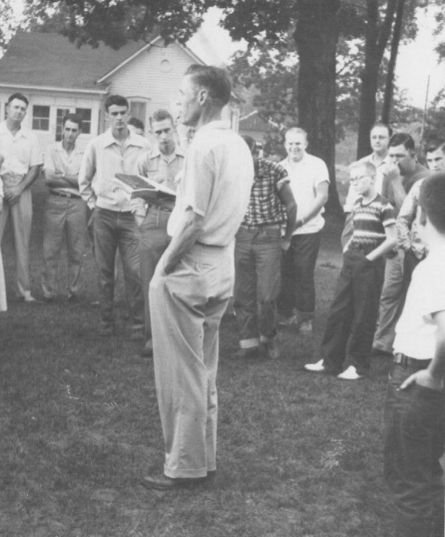
Brother Jack Morrow teaching boys at Youth Camp
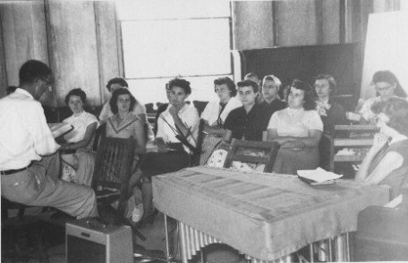
Girls’ Class at Camp too!
31

