9
_______________█_______________

CHRISTIANS AND SINNERS CONTRASTED
_____________________

A sinner is not a sinner because he commits acts of sin; but, he sins because he is a sinner. A statement like that calls for an explanation and an illustration! One does not have the measles because he breaks out with red bumps; but, he breaks out because he has the measles. The bumps do not cause the measles, but the disease of measles causes the bumps! The bad, wicked things that people do, does not make them sinners. They do wicked things because they are sinners.

THE QUESTION THEN WOULD BE: WHAT IS SIN? Sin is a nature that Adam and Eve acquired when they listened to the Devil and ate the forbidden fruit (Gen. 2:15-17 “And the LORD God took the man, and put him into the garden of Eden to dress it and to keep it. And the LORD God commanded the man, saying, Of every tree of the garden thou mayest freely eat: But of the tree of the knowledge of good and evil, thou shalt not eat of it: for in the day that thou eatest thereof thou shalt surely die.”; 3:17 “And unto Adam he said, Because thou hast hearkened unto the voice of thy wife, and hast eaten of the tree, of which I commanded thee, saying, Thou shalt not eat of it: cursed is the ground for thy sake; in sorrow shalt thou eat of it all the days of thy life;”). The sin nature has been transmitted from the father to his children ever since. It is like a disease. We are born with that sin nature; therefore, the whole human race has the disease of sin (Romans 3:23 “For all have sinned, and come short of the glory of God;”, 5:12,18,19 “Wherefore, as by one man sin entered into the world, and death by sin; and so death passed upon all men, for that all have sinned:” “Therefore as by the offence of one judgment came upon all men to condemnation; even so by the righteousness of one the free gift came upon all men unto justification of life. For as by one man's disobedience many were made sinners, so by the obedience of one shall many be made righteous.”).

HOW DOES THE DISEASE OF SIN MANIFEST ITSELF? If one yields to the sin nature, it will completely possess them until they are liable to do almost anything. Its manifestations are recorded in Galatians 5:19-21 (“Now the works of the flesh are manifest, which are these; Adultery, fornication, uncleanness, lasciviousness, Idolatry, witchcraft, hatred, variance, emulations, wrath, strife, seditions, heresies, Envyings, murders, drunkenness, revellings, and such like: of the which I tell you before, as I have also told you in time past, that they which do such things shall not inherit the kingdom of God.”).
53

Doctrinal Truths of the Bethel Ministerial Association

CAN ONE BE GOOD AND STILL BE A SINNER? Yes, one can be a good husband, a good wife, a good neighbor and a good citizen and still be a sinner. Being good does not change the sin nature which infects the entire human race, good or bad.

CAN ONE BE RELIGIOUS AND STILL BE A SINNER? Yes, one can be full of religious ideas, even join the church of his choice, and still be a sinner. In fact, the Devil, himself, is very religious!!

CAN ONE BE EDUCATED AND STILL REMAIN A SINNER? Yes, indeed!! Education does not affect the disease of sin. Remember, sin is a nature transmitted from our fathers. There is only one cure for the disease called sin.

CAN A SINNER GO TO HEAVEN? No, a sinner is not a citizen of heaven. Our citizenship must be changed while we are in this life. Heaven is only for a prepared people.

WHAT IS THE SINNER'S STANDING BEFORE GOD? He is a rebel and a criminal. God will deal with him as an outlaw (John 3:18,36 “He that believeth on him is not condemned: but he that believeth not is condemned already, because he hath not believed in the name of the only begotten Son of God.” “He that believeth on the Son hath everlasting life: and he that believeth not the Son shall not see life; but the wrath of God abideth on him.”).

DOES GOD HAVE A PENITENTIARY FOR THE OUTLAWS? Yes! Hell is God's penitentiary. You cannot kill the inner man since man has an eternal soul. But he can be penned up (Matt. 10:28 “And fear not them which kill the body, but are not able to kill the soul: but rather fear him which is able to destroy both soul and body in hell.”). A dumping ground is very essential to a city. Hell is God's dumping ground. The wages of sin is eternal separation from God (Rom. 6:23 “For the wages of sin is death; but the gift of God is eternal life through Jesus Christ our Lord.”; Rev. 20:11-15 “And I saw a great white throne, and him that sat on it, from whose face the earth and the heaven fled away; and there was found no place for them. And I saw the dead, small and great, stand before God; and the books were opened: and another book was opened, which is the book of life: and the dead were judged out of those things which were written in the books, according to their works. And the sea gave up the dead which were in it; and death and hell delivered up the dead which were in them: and they were judged every man according to their works. And death and hell were cast into the lake of fire. This is the second death. And whosoever was not found written in the book of life was cast into the lake of fire.”; Luke 16:19-31 “There was a certain rich man, which was clothed in purple and fine linen, and fared sumptuously every day: And there was a certain beggar named Lazarus, which was laid at his gate, full of sores, And desiring to be fed with the crumbs which fell from the rich man's table: moreover the dogs came and licked his sores. And it came to pass, that the beggar died, and was carried by the angels into Abraham's bosom: the rich man also died, and was buried; And in hell he lift up his eyes, being in torments, and seeth Abraham afar off, and Lazarus in his bosom. And he cried and said, Father Abraham, have mercy on me, and send Lazarus, that he may dip the tip of his finger in water, and cool my tongue; for I am tormented in this flame. But Abraham said, Son, remember that thou in thy lifetime receivedst thy good things, and likewise Lazarus evil things: but now he is comforted, and thou art tormented. And beside all this, between us and you there is a great gulf fixed: so that they which would pass from hence to you cannot; neither can they pass to us, that would come from thence. Then he said, I pray thee therefore, father, that thou wouldest send him to my father's house: For I have five brethren; that he may testify unto them, lest they also come into this place of torment. Abraham saith unto him, They have Moses and the prophets; let them hear them. And he said, Nay, father Abraham: but if one went unto them from the dead, they will repent. And he said unto him, If they hear not Moses and the prophets, neither will they be persuaded, though one rose from the dead.”).
54

Christians And Sinners Contrasted

WHAT IS THE CURE FOR THE DISEASE OF SIN? Sin is a terrible thing; therefore, it cost a tremendous price to effect a cure. THE CURE IS THE SHED BLOOD OF THE SON OF GOD as shown by the Scriptures which follow. Jesus said, "This is my blood of the New Testament which is shed for many for the remission of sins" (Matt. 26:28). Paul said, "Without the shedding of blood is no remission" (Heb. 9:22). John said, "The 'blood of Jesus Christ His Son cleanseth us from all sin" (1 John 1:7).

HOW DO SINNERS RECEIVE THE BENEFIT OF THAT HOLY BLOOD? In order to cure the disease of sin, God must give us a new life. This life is in His Son (1 John 5:11-13 “And this is the record, that God hath given to us eternal life, and this life is in his Son. He that hath the Son hath life; and he that hath not the Son of God hath not life. These things have I written unto you that believe on the name of the Son of God; that ye may know that ye have eternal life, and that ye may believe on the name of the Son of God.”). Therefore, we could not receive this new life and reject the Son of God. We must accept His death as our own personal sacrifice for sin. The sentence of death is upon us - He died in our place. THE LORD JESUS DID ALL HE WILL EVER DO WHEN HE GAVE HIS LIFE TO SAVE OUR SOULS. Now He offers us eternal life, if we will obey the Gospel (Acts 2:38 “Then Peter said unto them, Repent, and be baptized every one of you in the name of Jesus Christ for the remission of sins, and ye shall receive the gift of the Holy Ghost.”). To refuse to obey the Gospel makes one a Christ rejector, and that makes him a rebel - a criminal against God. For the results of refusing to obey the Gospel, read 2 Thess. 1:7,8 “And to you who are troubled rest with us, when the Lord Jesus shall be revealed from heaven with his mighty angels, In flaming fire taking vengeance on them that know not God, and that obey not the gospel of our Lord Jesus Christ:”

WHAT IS A CHRISTIAN? A Christian is ONE WHO HAS CEASED REBELLION by surrendering to God's plan of salvation. That is, he must believe, repent, and be baptized in the Name of Jesus Christ (John 3:16 “For God so loved the world, that he gave his only begotten Son, that whosoever believeth in him should not perish, but have everlasting life.”; Mark 16:16 “He that believeth and is baptized shall be saved; but he that believeth not shall be damned.”; Acts 2:38 “Then Peter said unto them, Repent, and be baptized every one of you in the name of Jesus Christ for the remission of sins, and ye shall receive the gift of the Holy Ghost.”). When one makes this surrender, he receives the Holy Ghost as a gift from God (Acts 2:38 and 5:32 “And we are his witnesses of these things; and so is also the Holy Ghost, whom God hath given to them that obey him.”).

WHAT DOES THE HOLY GHOST DO FOR THE ONE WHO MAKES THIS SURRENDER?
1. He generates a new nature within him (Titus 3:5 “Not by works of righteousness which we have done, but according to his mercy he saved us, by the washing of regeneration, and renewing of the Holy Ghost:”).
2. He produces a supernatural love for God (Rom. 5:5 “And hope maketh not ashamed; because the love of God is shed abroad in our hearts by the Holy Ghost which is given unto us.”). This kind of love makes one want to please God in everything he does.
3. He floods the born again life with a joy which is unspeakable and full of glory (1 Peter 1:8 “Whom having not seen, ye love; in whom, though now ye see him not, yet believing, ye rejoice with joy unspeakable and full of glory:”).
4. He bestows a peace which remains deep and lasting even in time of trouble (John 14:27 “Peace I leave with you, my peace I give unto you: not as the world giveth, give I unto you. Let not your heart be troubled, neither let it be afraid.”).

55

Doctrinal Truths of the Bethel Ministerial Association

A more complete description of what the Holy Ghost will produce through a yielded Christian is recorded in Gal. 5:22,23 (“But the fruit of the Spirit is love, joy, peace, longsuffering, gentleness, goodness, faith, Meekness, temperance: against such there is no law.”)and 1 Cor. 12th chapter. The Christian life is a happy life; it is also a healthy life. "The blessing of' God maketh rich and addeth no sorrow" (Prov. 10:22).

WHAT CAN A CHRISTIAN EXPECT IN THE END? A Christian, who is released from his body by death, goes immediately to Heaven. He receives a temporary body while he awaits his permanent, resurrected body (2 Cor. 5:1-4 “For we know that if our earthly house of this tabernacle were dissolved, we have a building of God, an house not made with hands, eternal in the heavens. For in this we groan, earnestly desiring to be clothed upon with our house which is from heaven: If so be that being clothed we shall not be found naked. For we that are in this tabernacle do groan, being burdened: not for that we would be unclothed, but clothed upon, that mortality might be swallowed up of life.”). As for the Christian who is alive at the coming of Jesus, his body will be changed "in a moment”, in the" twinkling of an eye," without going through death (1 Cor. 15:51-53 “Behold, I shew you a mystery; We shall not all sleep, but we shall all be changed, In a moment, in the twinkling of an eye, at the last trump: for the trumpet shall sound, and the dead shall be raised incorruptible, and we shall be changed. For this corruptible must put on incorruption, and this mortal must put on immortality.”; 1 Thess. 4:13-18 “But I would not have you to be ignorant, brethren, concerning them which are asleep, that ye sorrow not, even as others which have no hope. For if we believe that Jesus died and rose again, even so them also which sleep in Jesus will God bring with him. For this we say unto you by the word of the Lord, that we which are alive and remain unto the coming of the Lord shall not prevent them which are asleep. For the Lord himself shall descend from heaven with a shout, with the voice of the archangel, and with the trump of God: and the dead in Christ shall rise first: Then we which are alive and remain shall be caught up together with them in the clouds, to meet the Lord in the air: and so shall we ever be with the Lord. Wherefore comfort one another with these words.”).

WHAT KIND OF A BODY DO CHRISTIANS RECEIVE WHEN THIS CHANGE COMES? Christians will receive a body like the Lord Jesus Christ's resurrected body (Phil. 3:20-21 “For our conversation is in heaven; from whence also we look for the Saviour, the Lord Jesus Christ: Who shall change our vile body, that it may be fashioned like unto his glorious body, according to the working whereby he is able even to subdue all things unto himself.”). His resurrected body was a flesh, bone and spirit body. For a description of His resurrected body, read Luke 24:13-43 (“And, behold, two of them went that same day to a village called Emmaus, which was from Jerusalem about threescore furlongs. And they talked together of all these things which had happened. And it came to pass, that, while they communed together and reasoned, Jesus himself drew near, and went with them. But their eyes were holden that they should not know him. And he said unto them, What manner of communications are these that ye have one to another, as ye walk, and are sad? And the one of them, whose name was Cleopas, answering said unto him, Art thou only a stranger in Jerusalem, and hast not known the things which are come to pass therein these days? And he said unto them, What things? And they said unto him, Concerning Jesus of Nazareth, which was a prophet mighty in deed and word before God and all the people: And how the chief priests and our rulers delivered him to be condemned to death, and have crucified him. But we trusted that it had been he which should have redeemed Israel: and beside all this, to day is the third day since these things were done. Yea, and certain women also of our company made us astonished, which were early at the sepulchre; And when they found not his body, they came, saying, that they had also seen a vision of angels, which said that he was alive. And certain of them which were with us went to the sepulchre, and found it even so as the women had said: but him they saw not. Then he said unto them, O fools, and slow of heart to believe all that the prophets have spoken: Ought not Christ to have suffered these

56

Christians And Sinners Contrasted

things, and to enter into his glory? And beginning at Moses and all the prophets, he expounded unto them in all the scriptures the things concerning himself. And they drew nigh unto the village, whither they went: and he made as though he would have gone further. But they constrained him, saying, Abide with us: for it is toward evening, and the day is far spent. And he went in to tarry with them. And it came to pass, as he sat at meat with them, he took bread, and blessed it, and brake, and gave to them. And their eyes were opened, and they knew him; and he vanished out of their sight. And they said one to another, Did not our heart burn within us, while he talked with us by the way, and while he opened to us the scriptures? And they rose up the same hour, and returned to Jerusalem, and found the eleven gathered together, and them that were with them, Saying, The Lord is risen indeed, and hath appeared to Simon. And they told what things were done in the way, and how he was known of them in breaking of bread. And as they thus spake, Jesus himself stood in the midst of them, and saith unto them, Peace be unto you. But they were terrified and affrighted, and supposed that they had seen a spirit. And he said unto them, Why are ye troubled? and why do thoughts arise in your hearts? Behold my hands and my feet, that it is I myself: handle me, and see; for a spirit hath not flesh and bones, as ye see me have. And when he had thus spoken, he shewed them his hands and his feet. And while they yet believed not for joy, and wondered, he said unto them, Have ye here any meat? And they gave him a piece of a broiled fish, and of an honeycomb. And he took it, and did eat before them.”). Spirit takes the place of blood in a spiritual body.

WHAT WILL BE THE CHRISTIAN'S MODE OF TRAVEL WITH A SPIRITUAL BODY? He will travel like a thought! A spiritual body is not limited to natural laws. He will have access to all of God's creation. Read in Luke 24:31-36 (“And their eyes were opened, and they knew him; and he vanished out of their sight. And they said one to another, Did not our heart burn within us, while he talked with us by the way, and while he opened to us the scriptures? And they rose up the same hour, and returned to Jerusalem, and found the eleven gathered together, and them that were with them, Saying, The Lord is risen indeed, and hath appeared to Simon. And they told what things were done in the way, and how he was known of them in breaking of bread. And as they thus spake, Jesus himself stood in the midst of them, and saith unto them, Peace be unto you.”) how Jesus could appear and disappear! The Bible tells us we will have a body like His (Phil. 3:20,21 “For our conversation is in heaven; from whence also we look for the Saviour, the Lord Jesus Christ: Who shall change our vile body, that it may be fashioned like unto his glorious body, according to the working whereby he is able even to subdue all things unto himself.”).

WHAT IS GOD'S CHALLENGE TO YOU? God says to you, "CHOOSE YOU THIS DAY WHOM YOU WILL SERVE." God has already moved; it is your move next. Believe, repent, and be baptized in the Name of Jesus Christ (John 3:16; Mark 16:16; Acts 2:38).
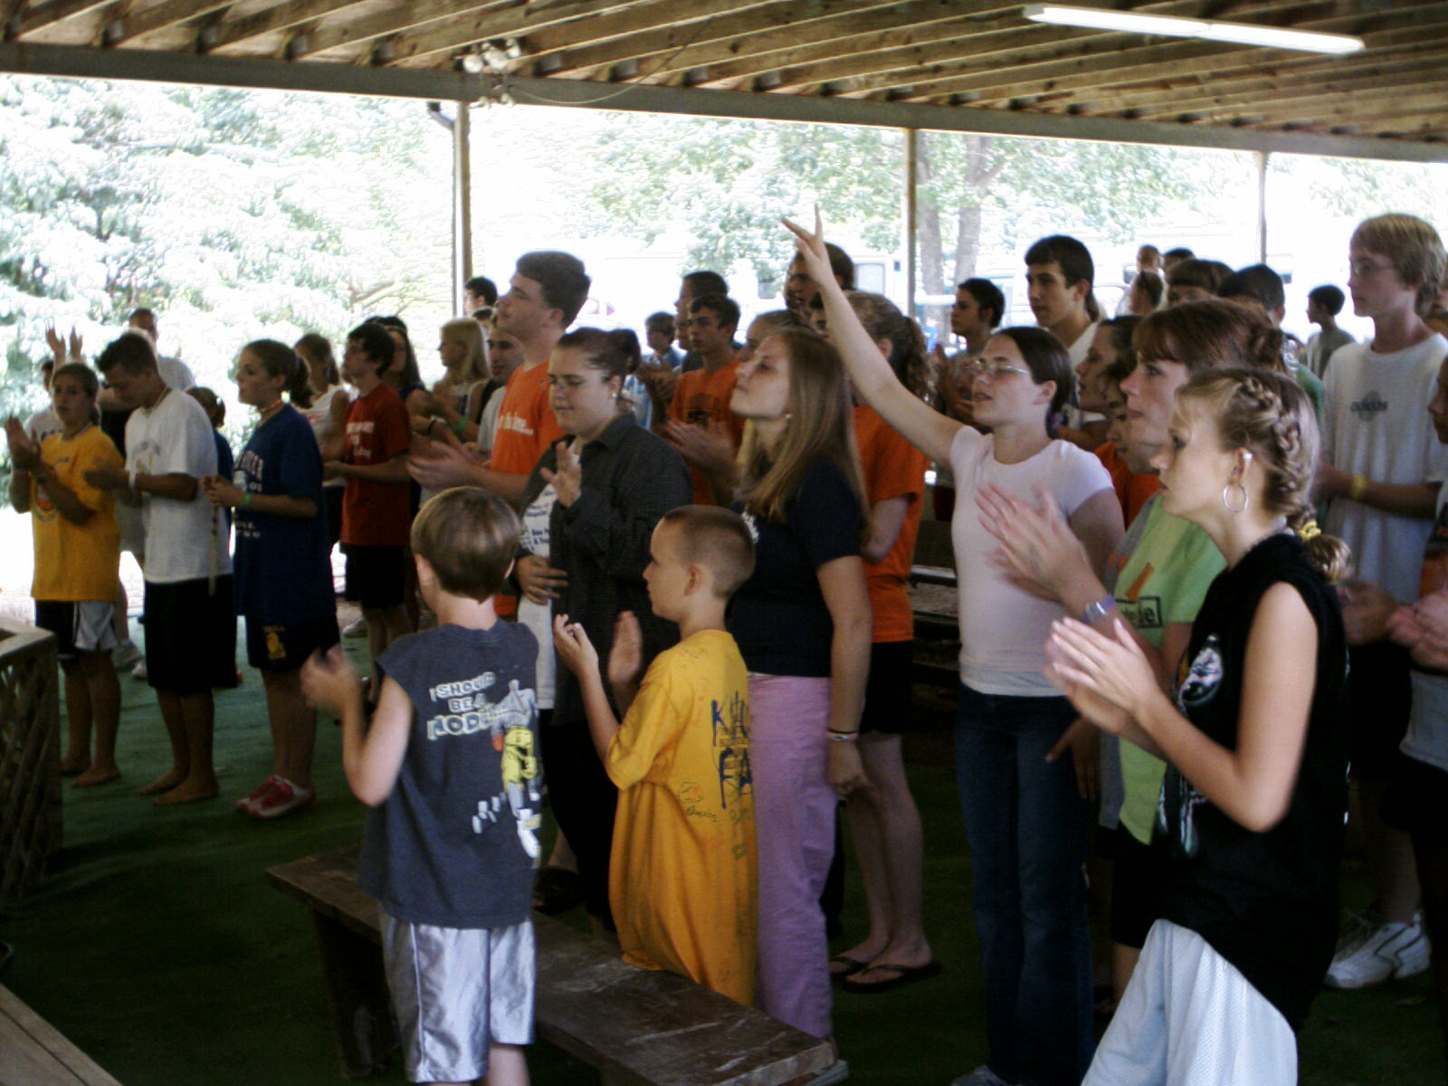
57

