6
_______________█_______________

JESUS IS THE NAME ABOVE EVERY NAME
An exposition of Phillipians 2:9-11
_____________________

"Wherefore God also hath highly exalted him, and given him the name which is above every name, that at the name of Jesus every knee should bow, of things in Heaven, and things in earth, and things under the earth, and that every tongue should confess that Jesus Christ is Lord, to the glory of God the Father." (Phillipians 2:9-11)

GOD EXALTED HIS SON IN THREE OUTSTANDING WAYS.

1. BY INCARNATING HIM, (See John 14:7-11 “If ye had known me, ye should have known my Father also: and from henceforth ye know him, and have seen him. Philip saith unto him, Lord, show us the Father, and it sufficeth us. Jesus saith unto him, Have I been so long time with you, and yet hast thou not known me, Philip? he that hath seen me hath seen the Father; and how sayest thou then, Show us the Father? Believest thou not that I am in the Father, and the Father in me? the words that I speak unto you I speak not of myself: but the Father that dwelleth in me, he doeth the works. Believe me that I am in the Father, and the Father in me: or else believe me for the very works' sake.”) making him the God-Man. The Incarnation took place when Jesus was begotten by the Holy Ghost, for he was Christ the Lord when he was born. (See Luke 2:11 “For unto you is born this day in the city of David a Saviour, which is Christ the Lord.”)

2. GOD EXALTED HIM BY GIVING HIM HIS OWN NAME, which is the name above every name. The name Jesus is above all the Old Testament names of Deity. All of these names are climaxed by his name which towers above them all. He was named by the Angel of the Lord. (See Matt. 1:20, 21 “But while he thought on these things, behold, the angel of the Lord appeared unto him in a dream, saying, Joseph, thou son of David, fear not to take unto thee Mary thy wife: for that which is conceived in her is of the Holy Ghost. And she shall bring forth a son, and thou shalt call his name JESUS: for he shall save his people from their sins.”) When the Angel said, "Thou shall call his name Jesus," he not only named a man, he named the God-Man. Jesus is God Incarnate.

38

Jesus Is The Name Above Every Name

3. GOD EXALTED HIM BY MAKING HIM KING. Jesus is King of Heaven now. Peter says, "He has gone into Heaven, and is on the right hand of God, Angels, Authorities and Powers being subject unto him." (See I Peter 3:22)

JESUS IS ALSO KING AND HEAD OF THE CHURCH. The Bible says we are translated into the Kingdom of God's Son, (See Col. 1: 13 “Who hath delivered us from the power of darkness, and hath translated us into the kingdom of his dear Son:”) There cannot be a Kingdom without a King. (Read I Tim. 1:17 “Now unto the King eternal, immortal, invisible, the only wise God, be honour and glory for ever and ever. Amen.” and Col. 1:18 “And he is the head of the body, the church: who is the beginning, the firstborn from the dead; that in all things he might have the preeminence.”)

THE BIBLE SAYS THE LORD SHALL BE KING OVER ALL THE EARTH. (See Zech. 14:9 “And the LORD shall be king over all the earth: in that day shall there be one LORD, and his name one.”) Therefore Jesus will set up an earthly Kingdom. The Angel said, "The Lord God shall give unto him the throne of his father David." (See Luke 1:30-33 “And the angel said unto her, Fear not, Mary: for thou hast found favour with God. And, behold, thou shalt conceive in thy womb, and bring forth a son, and shalt call his name JESUS. He shall be great, and shall be called the Son of the Highest: and the Lord God shall give unto him the throne of his father David: And he shall reign over the house of Jacob for ever; and of his kingdom there shall be no end.”) That means the Kingdom of David and Solomon will be rebuilt and spread over all the earth. (See Acts 15:15-18 “And to this agree the words of the prophets; as it is written, After this I will return, and will build again the tabernacle of David, which is fallen down; and I will build again the ruins thereof, and I will set it up: That the residue of men might seek after the Lord, and all the Gentiles, upon whom my name is called, saith the Lord, who doeth all these things. Known unto God are all his works from the beginning of the world.”)

AT THE NAME OF JESUS EVERY KNEE SHALL BOW. That means worship; it also means Jesus is God's name, for it is written, "Thou shalt worship the Lord thy God, and him only shalt thou serve." (See Matt. 4:10)

EVERY TONGUE SHALL CONFESS THAT JESUS CHRIST IS LORD. That means everyone must acknowledge Jesus to be God Incarnate. That is the way to glorify God the Father. God is Spirit. (See John 4:24 “God is a Spirit: and they that worship him must worship him in spirit and in truth.”) As Spirit he works in and through his Son, the man Christ Jesus.

WHAT THE NAME JESUS MEANS. Isaiah said, "His name (One name) shall be called Wonderful, Counsellor, The Mighty God, The Everlasting Father, The Prince of Peace. That does not mean God's Son had five names, it means his one name JESUS is the name of these five titles. (See Isa. 9:6 “For unto us a child is born, unto us a son is given: and the government shall be upon his shoulder: and his name shall be called Wonderful, Counsellor, The mighty God, The everlasting Father, The Prince of Peace.”) Isaiah also said his name shall be called Emmanuel. (See Isa. 7:14 “Therefore the Lord himself shall give you a sign; Behold, a virgin shall conceive, and bear a son, and shall call his name Immanuel.”) That means the name JESUS is the name of Emmanuel. (See Matt. 1:21-25 “And she shall bring forth a son, and thou shalt call his name JESUS: for he shall save his people from their sins. Now all this was done, that it might be fulfilled which was spoken of the Lord by the prophet, saying, Behold, a virgin shall be with child, and shall bring forth a son, and they shall call his name Emmanuel, which being

39

Doctrinal Truths of the Bethel Ministerial Association

interpreted is, God with us. Then Joseph being raised from sleep did as the angel of the Lord had bidden him, and took unto him his wife: And knew her not till she had brought forth her firstborn son: and he called his name JESUS.”) Emmanuel means God with us, and Jesus is God Incarnate.

JESUS SAID TO BAPTIZE IN THE NAME (ONE NAME) OF THE FATHER, AND OF THE SON, AND OF THE HOLY GHOST. (See Matt. 28: 19 “Go ye therefore, and teach all nations, baptizing them in the name of the Father, and of the Son, and of the Holy Ghost:”) Father, Son, and Holy Ghost are only titles; the name is JESUS. (See Acts 2:38 “Then Peter said unto them, Repent, and be baptized every one of you in the name of Jesus Christ for the remission of sins, and ye shall receive the gift of the Holy Ghost.”) Those who have been baptized with these titles said over them should be rebaptized in the name of Jesus. (See Acts 19:1-5 “And it came to pass, that, while Apollos was at Corinth, Paul having passed through the upper coasts came to Ephesus: and finding certain disciples, He said unto them, Have ye received the Holy Ghost since ye believed? And they said unto him, We have not so much as heard whether there be any Holy Ghost. And he said unto them, Unto what then were ye baptized? And they said, Unto John's baptism. Then said Paul, John verily baptized with the baptism of repentance, saying unto the people, that they should believe on him which should come after him, that is, on Christ Jesus. When they heard this, they were baptized in the name of the Lord Jesus.”)

PETER SAID, "NEITHER IS THERE SALVATION IN ANY OTHER, for there is none other name under Heaven given among men whereby we must be saved." (See Acts 4:12) That means since the Incarnation God's proper name has been Jesus. God is the only Saviour (See Isa. 43:10, 11 “Ye are my witnesses, saith the LORD, and my servant whom I have chosen: that ye may know and believe me, and understand that I am he: before me there was no God formed, neither shall there be after me. I, even I, am the LORD; and beside me there is no saviour.”) and Jesus is his saving name.

PAUL SAYS, "WHATSOEVER YE DO IN WORD OR DEED, DO ALL IN THE NAME OF THE LORD JESUS." The Bible teaches that everything in the early church was done in Jesus' name. Demons were cast out in that name, the sick were healed in that name, (See Mark 16: 17, 18 “And these signs shall follow them that believe; In my name shall they cast out devils; they shall speak with new tongues; They shall take up serpents; and if they drink any deadly thing, it shall not hurt them; they shall lay hands on the sick, and they shall recover.”) converts were baptized in that name. (See Acts 2:38 “Then Peter said unto them, Repent, and be baptized every one of you in the name of Jesus Christ for the remission of sins, and ye shall receive the gift of the Holy Ghost.”; 8:16 (“For as yet he was fallen upon none of them: only they were baptized in the name of the Lord Jesus.)”; 10:47,48 “Can any man forbid water, that these should not be baptized, which have received the Holy Ghost as well as we? And he commanded them to be baptized in the name of the Lord. Then prayed they him to tarry certain days.”; 19:1-5 “And it came to pass, that, while Apollos was at Corinth, Paul having passed through the upper coasts came to Ephesus: and finding certain disciples, He said unto them, Have ye received the Holy Ghost since ye believed? And they said unto him, We have not so much as heard whether there be any Holy Ghost. And he said unto them, Unto what then were ye baptized? And they said, Unto John's baptism. Then said Paul, John verily baptized with the baptism of repentance, saying unto the people, that they should believe on him which should come after him, that is, on Christ Jesus. When they heard this, they were baptized in the name of the Lord Jesus.”)

TO REJECT THE NAME JESUS AS GOD'S NAME means to reject Jesus for what he claimed to be. The Jews rejected him because he claimed to be God Incarnate, and God rejected them. (See Luke 13:34, 35 “O Jerusalem, Jerusalem, which killest the prophets,
40

Jesus Is The Name Above Every Name

and stonest them that are sent unto thee; how often would I have gathered thy children together, as a hen doth gather her brood under her wings, and ye would not! Behold, your house is left unto you desolate: and verily I say unto you, Ye shall not see me, until the time come when ye shall say, Blessed is he that cometh in the name of the Lord.”) Can we believe on Jesus and reject him as Incarnate God? The God that is in the Man Christ Jesus. (See II Cor. 5:19 “To wit, that God was in Christ, reconciling the world unto himself, not imputing their trespasses unto them; and hath committed unto us the word of reconciliation.”) is the only God I worship, and the only God I believe in.

THE BIBLE SAYS, "He that abideth in the doctrine of Christ, he hath both the Father and the Son." (See II John 1:9 “Whosoever transgresseth, and abideth not in the doctrine of Christ, hath not God. He that abideth in the doctrine of Christ, he hath both the Father and the Son.”) No one could receive Jesus without receiving the Father, for the Father is in Jesus. Jesus is both God and man; he is both Father and Son in one Image. (See Col.1: 15 “Who is the image of the invisible God, the firstborn of every creature:”)

THE POET MUST HAVE HAD THIS TRUTH IN MIND WHEN HE WROTE, "At the name of Jesus bowing, falling prostrate at his feet, King of Kings in Heaven we will crown him when our journey is complete."

JESUS, AS GOD THE SPIRIT, IS EVERYWHERE PRESENT. He is on earth and in Heaven at the same time. (See Jer. 23:23, 24 “Am I a God at hand, saith the LORD, and not a God afar off? Can any hide himself in secret places that I shall not see him? saith the LORD. Do not I fill heaven and earth? saith the LORD.”) Jesus said, "Where two or three are gathered together in my name, there am I in the midst of them." (See Matt. 18:20) There might be a million different groups gathered together, in different places, at the same time. That means Jesus would be a million different places, on earth, at the same time. And yet there is only one Spirit. (See Eph.4:4 “There is one body, and one Spirit, even as ye are called in one hope of your calling;”)

EACH INDIVIDUAL CHRISTIAN HAS JESUS IN HIM. (See II Cor. 13:5 “Examine yourselves, whether ye be in the faith; prove your own selves. Know ye not your own selves, how that Jesus Christ is in you, except ye be reprobates?”) Paul says, "If any man have not the Spirit of Christ he is none of his." (See Rom. 8:9 “But ye are not in the flesh, but in the Spirit, if so be that the Spirit of God dwell in you. Now if any man have not the Spirit of Christ, he is none of his.”) That means one must have the Holy Ghost to be a Christian, for the Holy Ghost is the Spirit of Christ. When one receives Jesus he receives the Holy Ghost. Jesus is not here as a man; he is only here as the Holy Ghost. Paul said, "Now the Lord is that Spirit." (See II Cor. 3:17 “Now the Lord is that Spirit: and where the Spirit of the Lord is, there is liberty.”)

WE NEED A REVIVAL THAT WILL RESTORE THESE TRUTHS. God is going to close the church age with the same message He used when he started it.

THESE TRUTHS WERE LOST AT THE NICENE COUNCIL 325 A.D. At that Council, 318 church bishops declared God to be a Trinity, three separate distinct persons, co-equal, co-eternal, and co-existent, none before or after another; but the whole three persons are co-eternal together and co-equal. (See Athanasian creed) That teaching does not make sense. It teaches three Spirits instead of one. It teaches three God's instead of one, each Spirit being a God. That kind of teaching will make unbelievers out of those who think.
41

Doctrinal Truths of the Bethel Ministerial Association

SINCE THE NICENE COUNCIL the trinity theory has taken the place of the one true God. The titles Father, Son, and Holy Ghost have been used instead of the name JESUS. Baptism has been an initiation into a church organization when it should be a burial with Christ. (See Rom. 6:3-5 “Know ye not, that so many of us as were baptized into Jesus Christ were baptized into his death? Therefore we are buried with him by baptism into death: that like as Christ was raised up from the dead by the glory of the Father, even so we also should walk in newness of life. For if we have been planted together in the likeness of his death, we shall be also in the likeness of his resurrection:”)

WE NEED A REVIVAL THAT WILL DELIVER US FROM THESE TRADITIONS, for they contradict facts and common sense. (See Matt. 15:6 “And honour not his father or his mother, he shall be free. Thus have ye made the commandment of God of none effect by your tradition.”) Each one should ask God to open his spiritual eyes so he can see these truths. (See Luke 24:45 “Then opened he their understanding, that they might understand the scriptures,”) When your eyes are opened you should obey the Gospel by being baptized in Jesus' name according to Acts 2:38. Then you should let your light shine wherever you go; others will see the light, and they too will obey the Gospel. In that way, God will restore these truths and send the revival we need today.

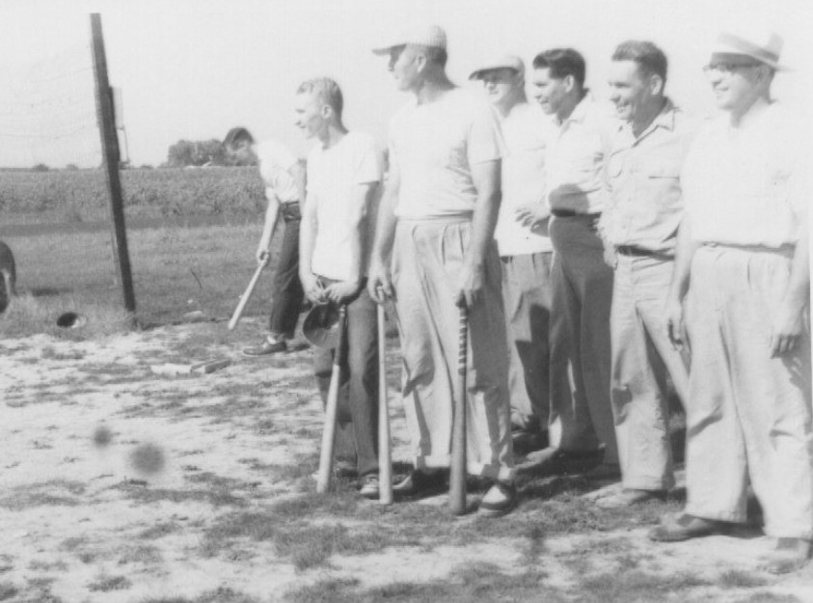
Ministers on the friendly fields of strife….baseball, “camp style.”

42

