15
_______________█_______________

Trinity and Oneness

Doctrines Contrasted
_____________________

1. THE TRINITY DOCTRINE TEACHES, that God the Father, God the Son, and God the Holy Ghost, are three separate distinct beings. Co-equal, Co-eternal, and Co-existence. They base this theory on the great commission, Mat.28:19, and the baptism of Jesus, Mat. 3:13-17.
Matt 28:19 “Go ye therefore, and teach all nations, baptizing them in the name of the Father, and of the Son, and of the Holy Ghost:”;
Matt 3:13-17 “Then cometh Jesus from Galilee to Jordan unto John, to be baptized of him. But John forbad him, saying, I have need to be baptized of thee, and comest thou to me? And Jesus answering said unto him, Suffer it to be so now: for thus it becometh us to fulfil all righteousness. Then he suffered him. And Jesus, when he was baptized, went up straightway out of the water: and, lo, the heavens were opened unto him, and he saw the Spirit of God descending like a dove, and lighting upon him: And lo a voice from heaven, saying, This is my beloved Son, in whom I am well pleased.”

THE ONENESS DOCTRINE TEACHES, that there is only, one Omni-present God, Deut. 6:4, with Mark 12:29, Isa. 43:10-11, 45:5, John 17:3. Only one first cause, only one Supreme Lord. They teach that Father, Son, and Holy Ghost are three manifestations of one God.
Deut 6:4 “Hear, O Israel: The LORD our God is one LORD:”;
Mark 12:29 “And Jesus answered him, The first of all the commandments is, Hear, O Israel; The Lord our God is one Lord:”;
Isa 43:10-11 “Ye are my witnesses, saith the LORD, and my servant whom I have chosen: that ye may know and believe me, and understand that I am he: before me there was no God formed, neither shall there be after me. I, even I, am the LORD; and beside me there is no saviour.”;
Isa 45:5 “I am the LORD, and there is none else, there is no God beside me: I girded thee, though thou hast not known me:”;
John 17:3 “And this is life eternal, that they might know thee the only true God, and Jesus Christ, whom thou hast sent.”

83

Doctrinal Truths of the Bethel Ministerial Association

2. THE TRINITY DOCTRINE TEACHES, that the Son of God was an Eternal Son, and that the Eternal Son came from heaven and Incarnated the child the Virgin Mary brought forth. They base this theory on Isa. 9:6. They say the child was born but the Son was given from heaven.
Isa 9:6 “For unto us a child is born, unto us a son is given: and the government shall be upon his shoulder: and his name shall be called Wonderful, Counsellor, The mighty God, The everlasting Father, The Prince of Peace.”

THE ONENESS DOCTRINE TEACHES, that the Sonship began with the Virgin birth, and that the child the Virgin Mary brought forth is the Son of God, Luke 1:34-35.
Luke 1:34-35 “Then said Mary unto the angel, How shall this be, seeing I know not a man? And the angel answered and said unto her, The Holy Ghost shall come upon thee, and the power of the Highest shall overshadow thee: therefore also that holy thing which shall be born of thee shall be called the Son of God.”

3. THE TRINITY DOCTRINE TEACHES, that the man Christ Jesus was Incarnated by the Eternal Son of God.

THE ONENESS DOCTRINE TEACHES, that the man Christ Jesus is the Son of God, Incarnated by the Eternal Father. John 10:30, 14:7-11, 17:3.
John 10:30 “I and my Father are one.”;
John 14:7-11 “If ye had known me, ye should have known my Father also: and from henceforth ye know him, and have seen him. Philip saith unto him, Lord, show us the Father, and it sufficeth us. Jesus saith unto him, Have I been so long time with you, and yet hast thou not known me, Philip? he that hath seen me hath seen the Father; and how sayest thou then, Show us the Father? Believest thou not that I am in the Father, and the Father in me? the words that I speak unto you I speak not of myself: but the Father that dwelleth in me, he doeth the works. Believe me that I am in the Father, and the Father in me: or else believe me for the very works' sake.”;
John 17:3 “And this is life eternal, that they might know thee the only true God, and Jesus Christ, whom thou hast sent.”

4. THE TRINITY DOCTRINE TEACHES, that the Son of God was Eternal without a beginning. They say He was co-eternal with the Father, and yet they say He was an Eternal Son of the Father. (Eternal means without beginning or end. Son implies a beginning.)

THE ONENESS DOCTRINE TEACHES, that the Son of God had a beginning. They teach that God begat the Son in the womb of the Virgin Mary, and that, that was His beginning as a Son, Mat. 1:18-25, Luke 1:30-35. God's Son was made of a woman, made under the law, Gal. 4:4-5, with Heb. 2:9-18.
Mat 1:18-25 “Now the birth of Jesus Christ was on this wise: When as his mother Mary was espoused to Joseph, before they came together, she was found with child of the Holy Ghost. Then Joseph her husband, being a just man, and not willing to make her a public example, was minded to put her away privily. But while he thought on these things, behold, the angel of the Lord appeared unto him in a dream, saying, Joseph, thou son of David, fear not to take unto thee Mary thy wife: for that which is conceived in her is of the Holy Ghost. And she shall bring forth a son, and thou shalt call his name JESUS: for he shall save his people from their sins. Now all this was done, that it might be fulfilled which was spoken of the Lord by the prophet, saying, Behold, a virgin shall be with child, and shall bring forth a son, and they shall call his name Emmanuel, which being interpreted is, God with us. Then Joseph being raised from sleep did as the angel of the Lord had bidden him, and took unto him his wife: And knew her not till she had brought forth her firstborn son: and he called his name JESUS.”;
84

Trinity and Oneness Doctrines Contrasted

Luke 1:30-35 “And the angel said unto her, Fear not, Mary: for thou hast found favour with God. And, behold, thou shalt conceive in thy womb, and bring forth a son, and shalt call his name JESUS. He shall be great, and shall be called the Son of the Highest: and the Lord God shall give unto him the throne of his father David: And he shall reign over the house of Jacob for ever; and of his kingdom there shall be no end. Then said Mary unto the angel, How shall this be, seeing I know not a man? And the angel answered and said unto her, The Holy Ghost shall come upon thee, and the power of the Highest shall overshadow thee: therefore also that holy thing which shall be born of thee shall be called the Son of God.”;
Gal 4:4-5 “But when the fulness of the time was come, God sent forth his Son, made of a woman, made under the law, To redeem them that were under the law, that we might receive the adoption of sons.”;
Heb 2:9-18 “But we see Jesus, who was made a little lower than the angels for the suffering of death, crowned with glory and honour; that he by the grace of God should taste death for every man. For it became him, for whom are all things, and by whom are all things, in bringing many sons unto glory, to make the captain of their salvation perfect through sufferings. For both he that sanctifieth and they who are sanctified are all of one: for which cause he is not ashamed to call them brethren, Saying, I will declare thy name unto my brethren, in the midst of the church will I sing praise unto thee. And again, I will put my trust in him. And again, Behold I and the children which God hath given me. Forasmuch then as the children are partakers of flesh and blood, he also himself likewise took part of the same; that through death he might destroy him that had the power of death, that is, the devil; And deliver them who through fear of death were all their lifetime subject to bondage. For verily he took not on him the nature of angels; but he took on him the seed of Abraham. Wherefore in all things it behoved him to be made like unto his brethren, that he might be a merciful and faithful high priest in things pertaining to God, to make reconciliation for the sins of the people. For in that he himself hath suffered being tempted, he is able to succour them that are tempted.”

THE ONENESS DOCTRINE TEACHES, that the Son of God was only Eternal in the mind of God. They teach that He was foreordained before the foundation of the world, but was manifest through the virgin birth I Pet. 1:20 (“Who verily was foreordained before the foundation of the world, but was manifest in these last times for you,”), Isa. 46:10 (“Declaring the end from the beginning, and from ancient times the things that are not yet done, saying, My counsel shall stand, and I will do all my pleasure:”), Rom. 4:17 (“As it is written, I have made thee a father of many nations, before him whom he believed, even God, who quickeneth the dead, and calleth those things which be not as though they were.”). When it is God's Eternal purpose to do something He speaks of it as though it is already done. II Tim. 1:9-10 (“Who hath saved us, and called us with an holy calling, not according to our works, but according to his own purpose and grace, which was given us in Christ Jesus before the world began, But is now made manifest by the appearing of our Saviour Jesus Christ, who hath abolished death, and hath brought life and immortality to light through the gospel:”), Eph. 1:3-4 (“Blessed be the God and Father of our Lord Jesus Christ, who hath blessed us with all spiritual blessings in heavenly places in Christ: According as he hath chosen us in him before the foundation of the world, that we should be holy and without blame before him in love:”), John 17:5 (“And now, O Father, glorify thou me with thine own self with the glory which I had with thee before the world was.”) and 24 (“Father, I will that they also, whom thou hast given me, be with me where I am; that they may behold my glory, which thou hast given me: for thou lovedst me before the foundation of the world.”).

5. THE TRINITY DOCTRINE TEACHES, that Jesus sitting on God's right hand, I Peter 3:22, means that the Son God, is sitting beside the Father God. Two beings
sitting side by side in heaven.

85

Doctrinal Truths of the Bethel Ministerial Association

THE ONENESS DOCTRINE TEACHES, that Jesus sitting on God's right hand, means He has been exalted to a place of favour, power, and authority. Compare these scriptures on the right hand--I Peter 3:22 “Who is gone into heaven, and is on the right hand of God; angels and authorities and powers being made subject unto him.”, I Cor. 1:24 “But unto them which are called, both Jews and Greeks, Christ the power of God, and the wisdom of God.”, Isa. 48:13 “Mine hand also hath laid the foundation of the earth, and my right hand hath spanned the heavens: when I call unto them, they stand up together.”, Psa.109:31 “For he shall stand at the right hand of the poor, to save him from those that condemn his soul.”, Isa. 63:12 “That led them by the right hand of Moses with his glorious arm, dividing the water before them, to make himself an everlasting name?”, Psa. 16:8 “I have set the LORD always before me: because he is at my right hand, I shall not be moved.”.

6. THE TRINITY DOCTRINE TEACHES, that when Jesus prayed it was God the Son praying to God the Father.

THE ONENESS DOCTRINE TEACHES, that when Jesus prayed it was the man Christ Jesus (the Son of God) praying to His Father who is the only true God, John 17:3 “And this is life eternal, that they might know thee the only true God, and Jesus Christ, whom thou hast sent.”. Jesus was a union of God and man through the Virgin birth, John 10:30 “I and my Father are one.”. He prayed as man, not as God. God does not need to pray.

7. THE TRINITY DOCTRINE TEACHES, that the Spirit of Jesus and the Holy Ghost are two different Spirits. They say one can have the Spirit of Jesus and be born again according to John 3:5 “Jesus answered, Verily, verily, I say unto thee, Except a man be born of water and of the Spirit, he cannot enter into the kingdom of God.”, and yet not have the Holy Ghost.

THE ONENESS DOCTRINE TEACHES, that the Spirit of Jesus is the Holy Ghost, Read Eph. 4:4 “There is one body, and one Spirit, even as ye are called in one hope of your calling;”, Mat. 18:20 “For where two or three are gathered together in my name, there am I in the midst of them.”, 28:20 “Teaching them to observe all things whatsoever I have commanded you: and, lo, I am with you alway, even unto the end of the world. Amen.”, John 14:16-20 “And I will pray the Father, and he shall give you another Comforter, that he may abide with you for ever; Even the Spirit of truth; whom the world cannot receive, because it seeth him not, neither knoweth him: but ye know him; for he dwelleth with you, and shall be in you. I will not leave you comfortless: I will come to you. Yet a little while, and the world seeth me no more; but ye see me: because I live, ye shall live also. At that day ye shall know that I am in my Father, and ye in me, and I in you.”, Col. 1:27 “To whom God would make known what is the riches of the glory of this mystery among the Gentiles; which is Christ in you, the hope of glory:”, II Cor. 3:17 “Now the Lord is that Spirit: and where the Spirit of the Lord is, there is liberty.”. There is a difference in receiving the Spirit and being filled with the Spirit, but it is all the same Spirit. It must be remembered that Jesus Christ was God manifest in the flesh, I Tim. 3:16 “And without controversy great is the mystery of godliness: God was manifest in the flesh, justified in the Spirit, seen of angels, preached unto the Gentiles, believed on in the world, received up into glory.”, II Cor. 5:19 “To wit, that God was in Christ, reconciling the world unto himself, not imputing their trespasses unto them; and hath committed unto us the word of reconciliation.”. The Father was Incarnate in the Son, John 14:7-11 “If ye had known me, ye should have known my Father also: and from henceforth ye know him, and have seen him. Philip saith unto him, Lord, show us the Father, and it sufficeth us. Jesus saith unto him, Have I been so long time with you, and yet hast thou not known me, Philip? he that hath seen me hath seen the Father; and how sayest thou then, Show us the Father? Believest thou not that I am in the Father, and the Father in
86

Trinity and Oneness Doctrines Contrasted

me? the words that I speak unto you I speak not of myself: but the Father that dwelleth in me, he doeth the works. Believe me that I am in the Father, and the Father in me: or else believe me for the very works' sake.”. “He was the image of the invisible God," Col. 1:15 “Who is the image of the invisible God, the firstborn of every creature:”. "In Him dwelleth all the fullness of the Godhead bodily," Col. 2:9 “For in him dwelleth all the fulness of the Godhead bodily.”.

8. THE TRINITY DOCTRINE TEACHES, that Father, Son, and Holy Ghost are three distinct proper names, and that believers should be baptized into three names. They base this theory on Mat. 28:19 “Go ye therefore, and teach all nations, baptizing them in the name of the Father, and of the Son, and of the Holy Ghost:”.

THE ONENESS DOCTRINE TEACHES, that the NAME of the Father, Son, and Holy Ghost is one NAME, and that, that NAME translated into English language is JESUS. This truth is revealed in Acts 2:38 “Then Peter said unto them, Repent, and be baptized every one of you in the name of Jesus Christ for the remission of sins, and ye shall receive the gift of the Holy Ghost.”, John 5:43 “I am come in my Father's name, and ye receive me not: if another shall come in his own name, him ye will receive.”, Phil. 2:9-11 “Wherefore God also hath highly exalted him, and given him a name which is above every name: That at the name of Jesus every knee should bow, of things in heaven, and things in earth, and things under the earth; And that every tongue should confess that Jesus Christ is Lord, to the glory of God the Father.”, Heb. 1:4 “Being made so much better than the angels, as he hath by inheritance obtained a more excellent name than they.”. The Oneness Doctrine teaches that we should do what Jesus said, and not just say what He said.

9. THE TRINITY DOCTRINE TEACHES, that the Oneness of Father and Son in John 10:30 (“I and my Father are one.”) is that they work together in harmony and get along together.

THE ONENESS DOCTRINE TEACHES that the Oneness of Father and Son in John 10:30 is a union of Father and Son through the Virgin birth. That is, the Father was Incarnated in the Son, John 14:7-11. God was manifest in the flesh, I Tim. 3:16.

10. THE TRINITY DOCTRINE TEACHES, that the Father and Son worked together in creation. They base this theory on Gen.1:26, which says, "Let us make man in our image."

THE ONENESS DOCTRINE TEACHES, that God refers to Himself as US, WE, and OUR as a mark of distinction to mean I. Like a King or a great ruler uses the word WE. See the word WE in your dictionary. Ministers almost always refer to themselves as WE. They hardly ever say I when referring to themselves. The Bible says God made the world by Himself, Gen 1:1 “In the beginning God created the heaven and the earth.”, Isa. 44:24 “Thus saith the LORD, thy redeemer, and he that formed thee from the womb, I am the LORD that maketh all things; that stretcheth forth the heavens alone; that spreadeth abroad the earth by myself;”. He did not have a helper.

These two schools of thought are before the religious world. The Trinity theory is by far the most popular, as it came from the Athanasian creed, down through the Catholic church and on into Protestantism. Each individual should know both sides of this great question and trust God to reveal light to you. Keep your heart open and be willing to pay the price for light. Truth is very costly. It cost John the Baptist his head. Truth caused Jesus to be

87

Doctrinal Truths of the Bethel Ministerial Association

nailed to the cross, John 18:37-38 “Pilate therefore said unto him, Art thou a king then? Jesus answered, Thou sayest that I am a king. To this end was I born, and for this cause came I into the world, that I should bear witness unto the truth. Every one that is of the truth heareth my voice. Pilate saith unto him, What is truth? And when he had said this, he went out again unto the Jews, and saith unto them, I find in him no fault at all.”, John 14:6 “Jesus saith unto him, I am the way, the truth, and the life: no man cometh unto the Father, but by me.”. The Martyrs laid down their lives for the truth. Truth might cause you to be put out of your church and be ostracized as a heretic. Be willing to pay the price and God will reveal His truth to you. "Buy the truth and sell it not," Prov 23:23. This means pay any price the truth may cost, but don't sell out at any price.

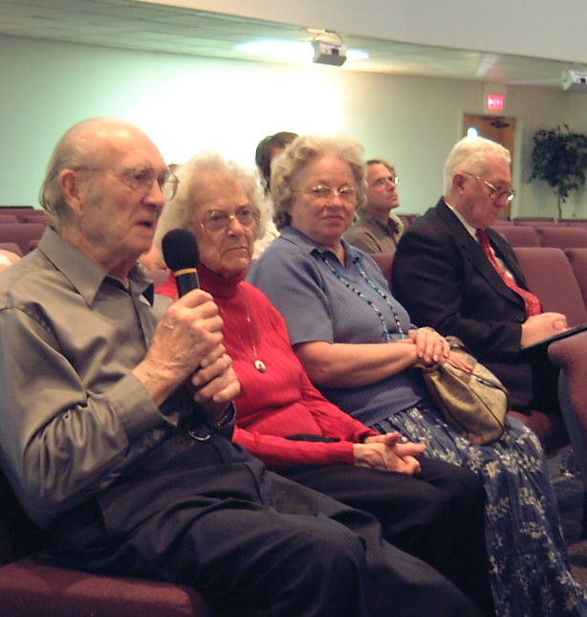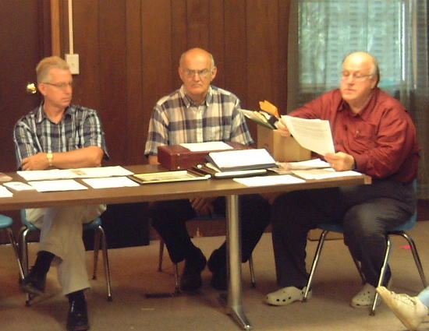
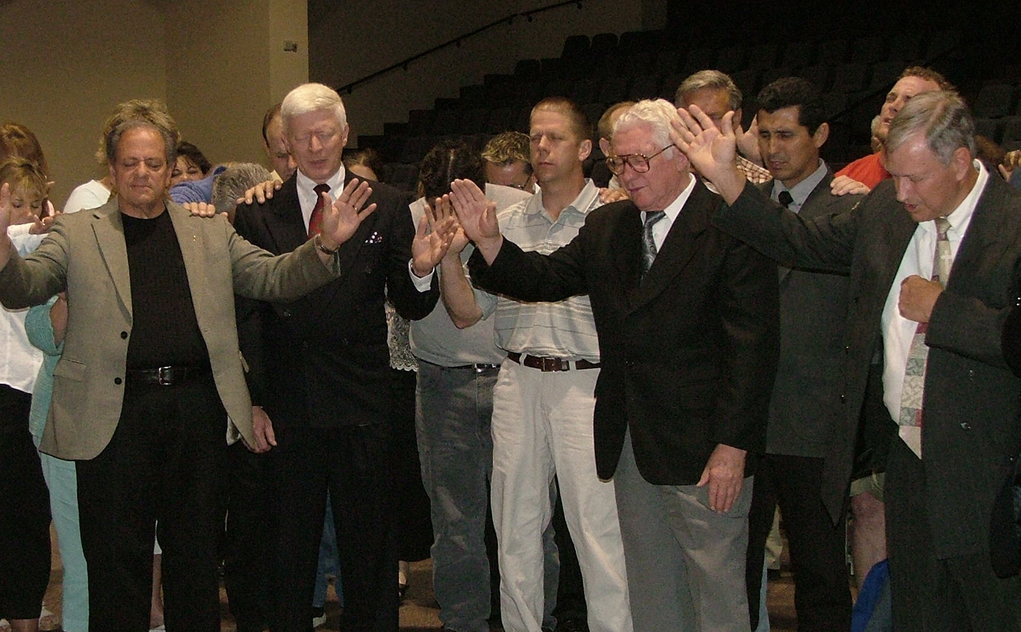

88

